Hello!
The new Exchange Bank mobile banking application is here. If you are an iPhone user, no action is required because your application should automatically update to the new experience – if it doesn’t, uninstall and re-install. If you are an Android user you will need to download the new application from the Google Playstore. If you login to the old application, you will see the following message:
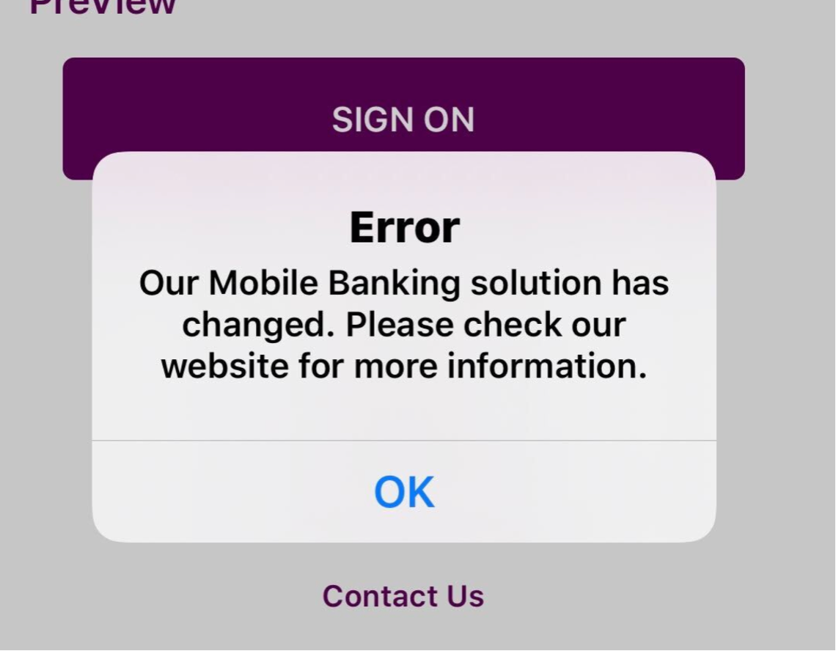
We are excited for this upgrade that introduces the following update:
- Touch ID & Face ID for iPhone & Android
- Sleek new design with an improved user experience & interface
- New authentication features, including one-time pin*

There is also an update for text banking. The new code is 678-498-7617.
Please contact us at 256.547.2572 if you have any issues with the new application. We greatly appreciate you choosing us for all your banking needs!

